**Integration Oracle Weblogic Server with Oracle Enterprise Manager Cloud Control**

Oracle Weblogic Server 12c (vm 1)

Oracle Database 12.1.0.2 (vm 2)

Oracle Enterprise Manager Cloud Control 13c (vm 2)

OS: Oracle linux 6.6

**Pre-Installation:**

-ONBOOT set for interface

-Hostname set and made an entry in /etc/hosts

-iptables disbled

-SElinux disbabled

**Weblogic server installation : (VM 1)**

**Software**

[Java Development Kit](http://www.oracle.com/technetwork/java/javase/downloads/jdk8-downloads-2133151.html) - 8u144 jdk-8u144-linux-x64.tar.gz

[Fusion Middleware Infrastructure Installer](http://www.oracle.com/technetwork/middleware/weblogic/downloads/wls-for-dev-1703574.html) - fmw_12.2.1.3.0_infrastructure_Disk1_1of1.zip

groupadd -g 54321 oinstall

useradd -u 54321 -g oinstall oracle

passwd oracle

Create a new group and user.

groupadd -g 54321 oinstall

useradd -u 54321 -g oinstall oracle

passwd oracle

Create the directories in which the Oracle software will be installed.

mkdir -p /u01/app/oracle/product/12.2.1

mkdir -p /u01/app/oracle/config/domains

mkdir -p /u01/app/oracle/config/applications

chown -R oracle:oinstall /u01

chmod -R 775 /u01/

Append the following entries into the "/home/oracle/.bash_profile" file.

# Adjust paths as required.

export ORACLE_BASE=/u01/app/oracle

export ORACLE_HOME=$ORACLE_BASE/product/12.2.1

export MW_HOME=$ORACLE_HOME

export WLS_HOME=$MW_HOME/wlserver

export WL_HOME=$WLS_HOME

export DOMAIN_BASE=$ORACLE_BASE/config/domains

export DOMAIN_HOME=$DOMAIN_BASE/mydomain

export JAVA_HOME=/u01/app/oracle/jdk1.8.0_144

export PATH=$JAVA_HOME/bin:$PATH

Install the JDK.

# su - oracle

$ cd $ORACLE_BASE

$ tar -xvzf /tmp/jdk-8u144-linux-x64.gz

Amend the "/etc/security/limits.d/90-nproc.conf" file, making the following change.

# From

* soft nproc 1024

#To

* - nproc 16384

## Installation

Run the installer as the "oracle" user.

$ unzip fmw_12.2.1.2.0_infrastructure_Disk1_1of1.zip

$ $JAVA_HOME/bin/java -jar fmw_12.2.1.2.0_infrastructure.jar

If this is is the first installation on the machine you will need to specify an inventory location. Enter the inventory location, like "/u01/app/oraInventory" and click the "OK" button.

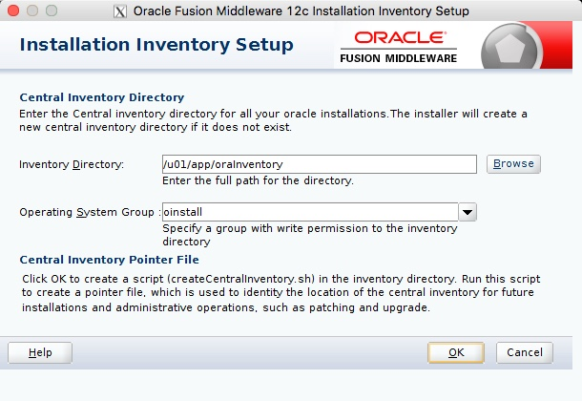

Click the "Next" button on the welcome screen.

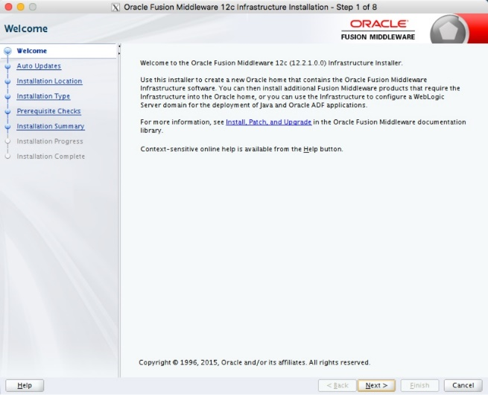

Select the "Skip Auto Updates" options, then click the "next" button.

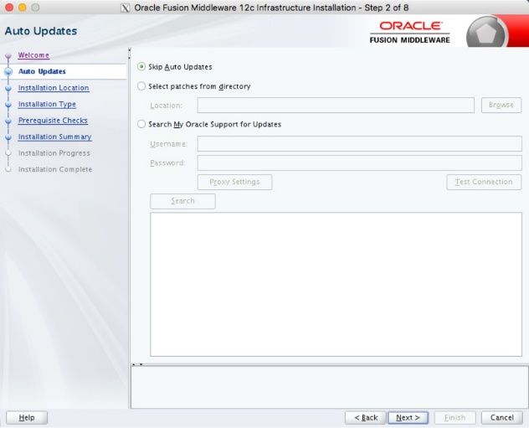

Enter the middleware home ("/u01/app/oracle/product/12.2.1") and click the "Next" button.

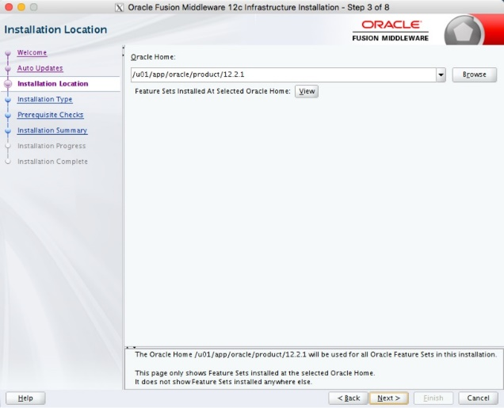

Accept the "Fusion Middleware Infrastructure" option by clicking the "Next" button.

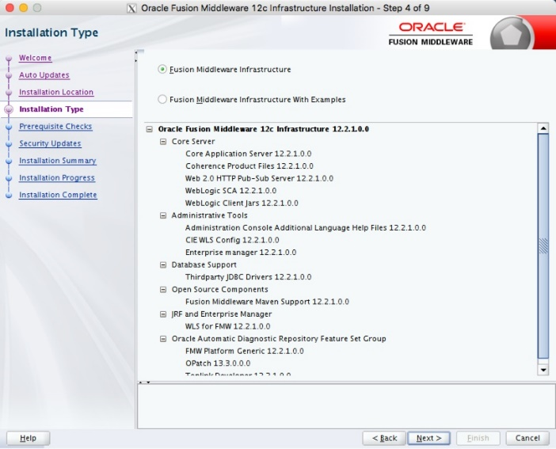

Wait for the prerequisite checks to complete. If there are failures, correct them and rerun the checks. If there are no failures, click the "Next" button.

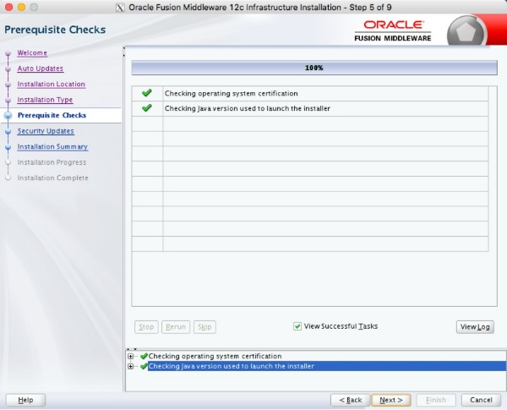

Either enter your support details, or uncheck the security updates checkbox. Click the "Next" button. If you chose not to receive security updates, click the "Yes" button on the warning dialog.

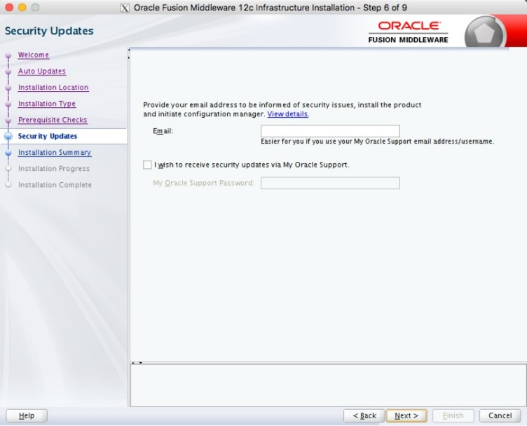

If you are happy with the summary information, click the "Install" button.

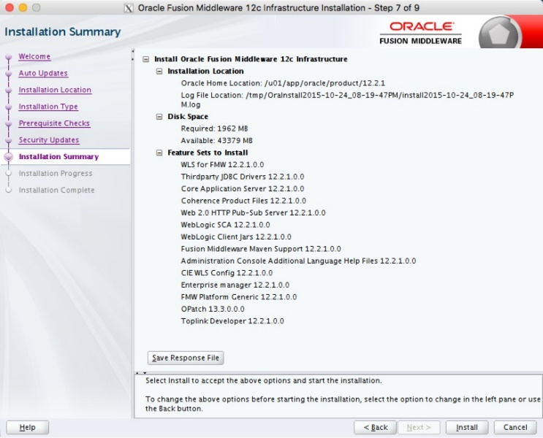

Wait for the installation to complete, then click the "Next" button.

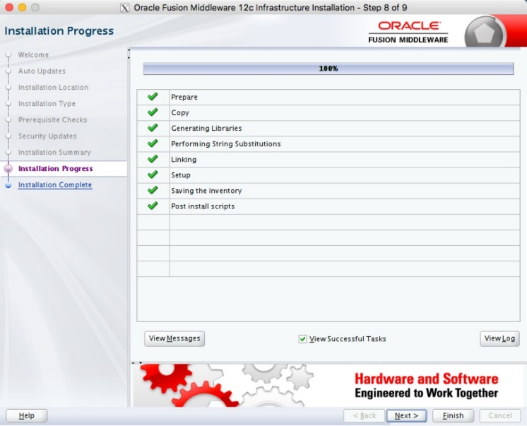

On the installation complete screen, click the "Finish" button to launch the Configuration Wizard.

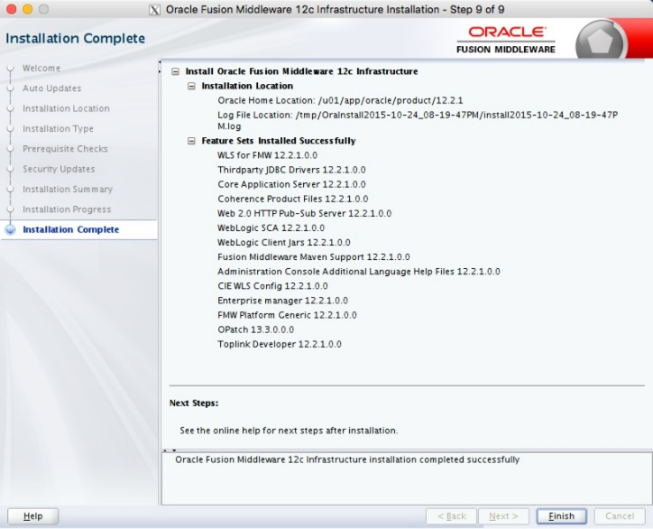

If you are doing an installation for Oracle Forms and Reports Services, you don't need to create the domain at this point, so stop here.

## Create Domain

Launch the Configuration Wizard with the following command.

$ $ORACLE_HOME/oracle_common/common/bin/config.sh

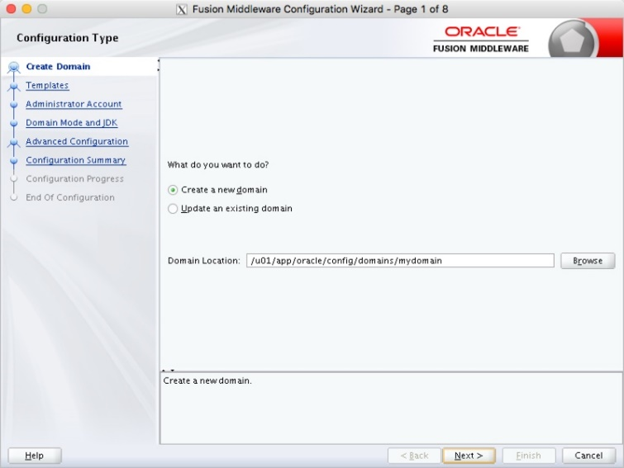

Select the required product template and click the "Next" button.

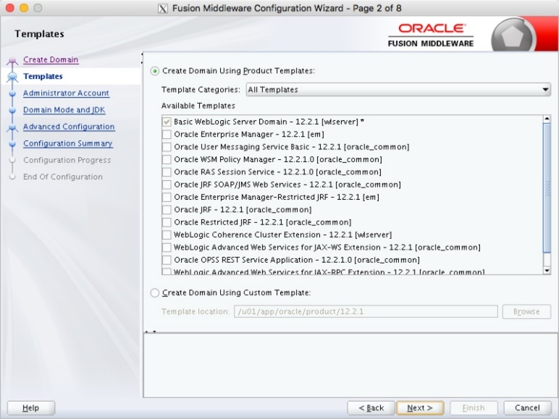

Enter the administrator credentials and click the "Next" button.

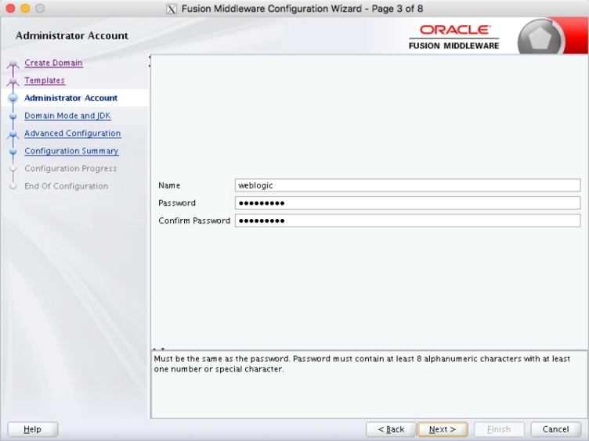

Enter the domain mode and JDK details, then click the "Next" button.

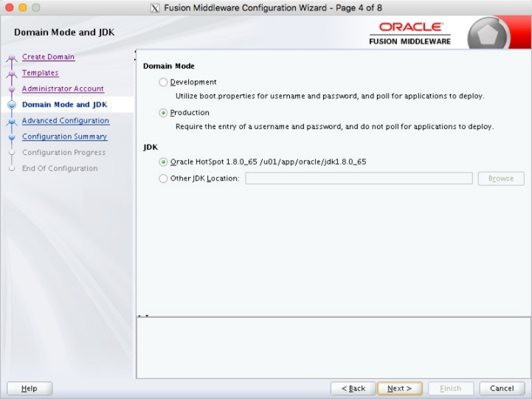

Select any required advanced configuration options. For this example I ignored the advanced configuration. Click the "Next" button.

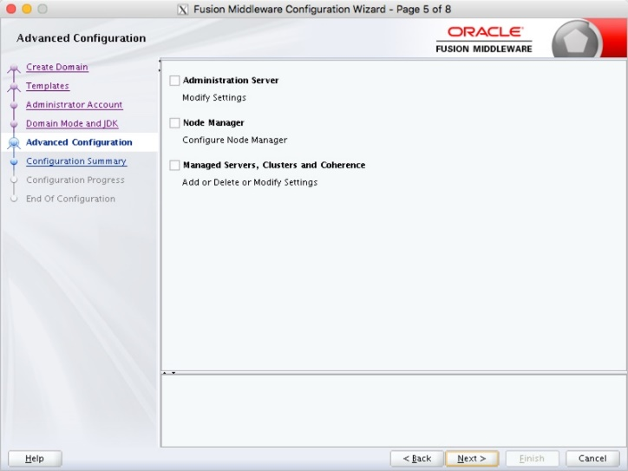

If you are happy with the configuration summary screen, click the "Create" button.

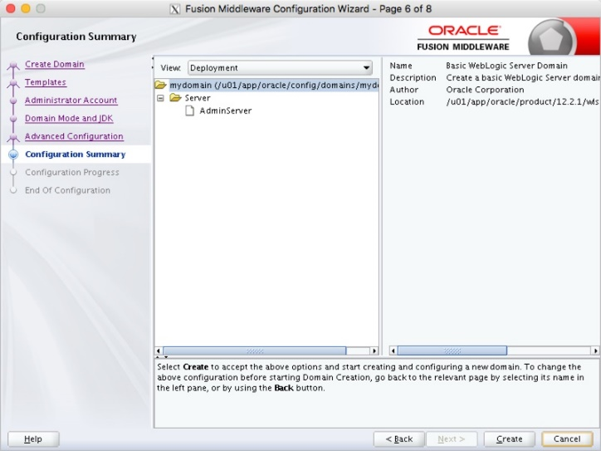

Once the domain is created, click the "Next" button.

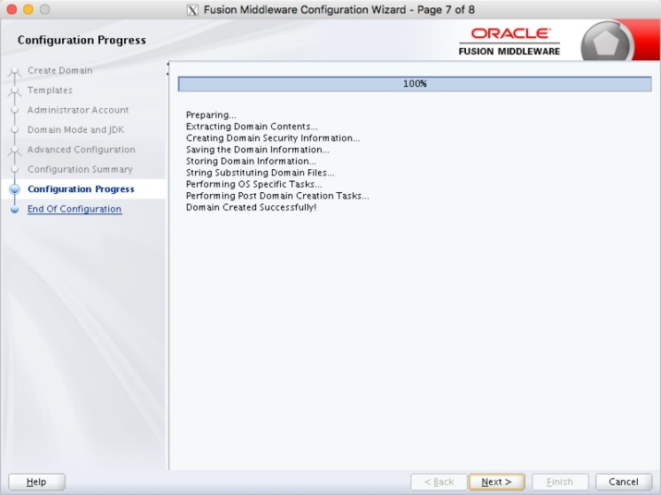

Make a note of the Admin Server URL and click the "Finish" button.

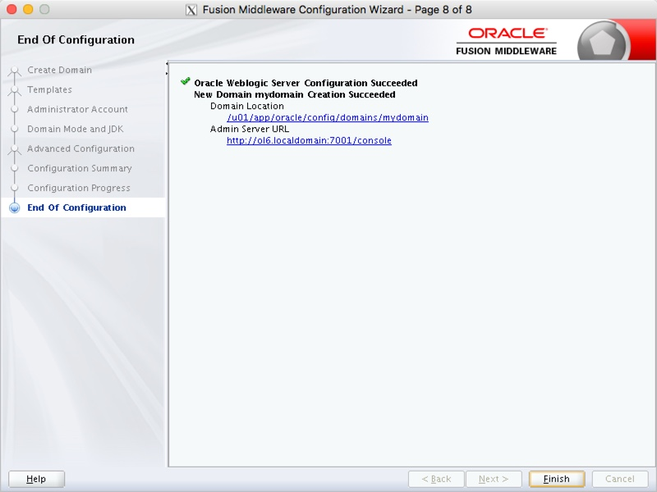

$ $DOMAIN_HOME/startWebLogic.sh &

Once the server is started you can access the administrator console using the http://hostname:port/console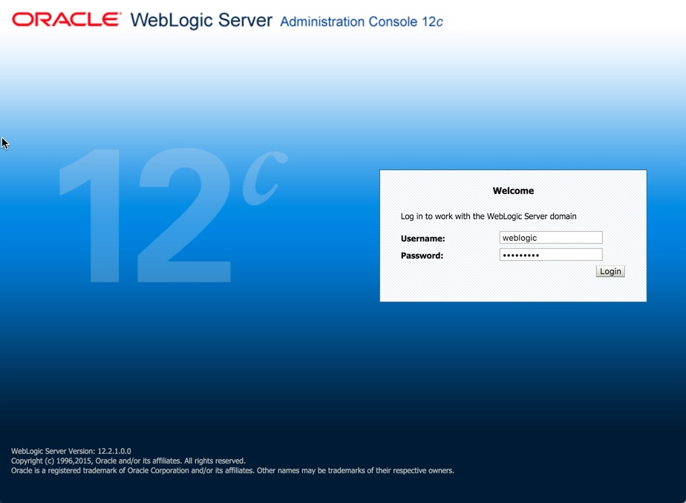

**Oracle Enterprise manager installation: (VM 2)**

**Software**

Download the following software:

[Oracle Database (x86_64) 12.1.0.2 Enterprise Edition](http://www.oracle.com/technetwork/database/enterprise-edition/downloads/index.html)

[Enterprise Manager Cloud Control 13c Release 1 (13.1.0.0) (x86_64)](http://www.oracle.com/technetwork/oem/grid-control/downloads/index.html)

[13.1.0.0 DB Template for EM 13.1.0.0 on Linux x86-64](http://www.oracle.com/technetwork/oem/enterprise-manager/downloads/db-templates-2767916.html)

**Database installation:**

**Operating System Prerequisites**

Assuming you have a working Yum repository, you can install the required operating

system dependencies for the database software with the following command:

yum install gcc gcc-c++ compat-libstdc++-33 glibc-devel libstdc++-devel \

elfutils-libelf-devel glibc-devel libaio-devel sysstat perl-URI \

bitstream-vera-fonts xorg-x11-xinit unixODBC unixODBC-devel xorg-x11-xinit rsync \

ksh

**Creating the Database User Accounts and Groups**

**1.** Create two groups (dba and oinstall) with the following commands:

/usr/sbin/groupadd dba

/usr/sbin/groupadd oinstall

**2.** Create the oracle user, and specify oinstall as the primary group and dba as the

secondary group, with the following command:

/usr/sbin/useradd -g oinstall -G dba oracle

**3.** Set the oracle user password with the following command:

passwd oracle

**Configuring the Kernel Parameter Settings (Set shmmni parameters also required for configuring database)**

**1.** Modify the /etc/sysctl.conf file to satisfy the Oracle installer’s requirements by

adding the following lines:

kernel.sem = 250 32000 100 128

net.ipv4.ip_local_port_range = 9000 65500

net.core.rmem_default = 4194304

net.core.rmem_max = 4194304

net.core.wmem_default = 262144

net.core.wmem_max = 1048576

fs.aio-max-nr = 1048576

fs.file-max = 6815744

**2.** Make these changes effective immediately with the following command:

/sbin/sysctl –p

**Setting Shell Limits for the Oracle User**

**1.** To improve the performance of the software, you must increase the shell limits for

the oracle user. Add the following lines to the /etc/security/limits.conf file:

oracle soft nproc 2047

oracle hard nproc 16384

oracle soft nofile 1024

oracle hard nofile 65536

**2.** If not already present, add the following lines to the /etc/pam.d/login file:

session required /lib64/security/pam_limits.so

session required pam_limits.so

**3.** Depending on the oracle user's default shell, you need to make changes to it. For

the Bourne, Bash, or Korn shell, add the following lines to the bottom of the

/etc/profile file:

if [ $USER = "oracle" ]; then

if [ $SHELL = "/bin/ksh" ]; then

ulimit -p 16384

ulimit -n 65536

else

ulimit -u 16384 -n 65536

fi

fi

Create the necessary subdirectories in the mount point directory that you

identified and set the appropriate owner, group, and permissions for them using

commands similar to the following:

mkdir -p /u01/app

chown -R oracle:oinstall /u01

chmod -R 775 /u01/app

**Configuring the Oracle User’s Environment and Installing the**

**Database**

**1.** Logon to the system as the oracle user.

**2.** Add or edit the umask setting in the ~/.bash_profile file to the following:

umask 022

**3.** Make the setting active for the current shell by issuing the following command:

. ./.bash_profile

**4.** Set the ORACLE_BASE environment variable to define the location of the root of the

Oracle directory tree:

export ORACLE_BASE=/u01/app/oracle

**5.** Unzip the Oracle database installation zip file. This creates the directory database.

Then, run the graphical installer (note this will not run under user root). Ensure

that your X Window environment is properly set up. In addition, when logging on

remotely with SSH, ensure X forwarding is enabled. Use the following commands:

cd <location of the zip file>

unzip linux_11gR2_database.zip

./database/runInstaller

***Specify Installation Location Dialog***



***Specify Inventory Directory and Credentials Dialog***



When installation is almost complete, you are prompted to run two scripts,

orainstRoot.sh and root.sh, as root.



**OEM Installation:-**

Setup required for oem installation

em13100_linux64bin, em13100_linux64-2.zip, em13100_linux64-3.zip, em13100_linux64-4.zip

12.1.0.2.0_Database_Template_for_EM13_1_0_0_0_Linux_x64.zip

yum install make -y

yum install binutils -y

yum install gcc -y

yum install libaio -y

yum install glibc-common -y

yum install libstdc++ -y

yum install libXtst -y

yum install sysstat -y

yum install glibc -y

yum install glibc-devel -y

yum install glibc-devel.i686 -y

$ cd $ORACLE_HOME/assistants/dbca/templates

$ unzip /tmp/12.1.0.2.0_Database_Template_for_EM13_1_0_0_0_Linux_x64.zip

$ dbca

Select the "Create Database" option and click the "Next" button.

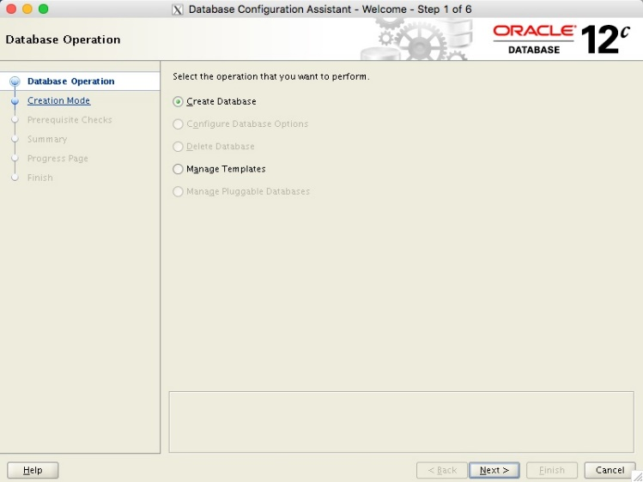

Select the "Advanced Mode" option and click the "Next" button.

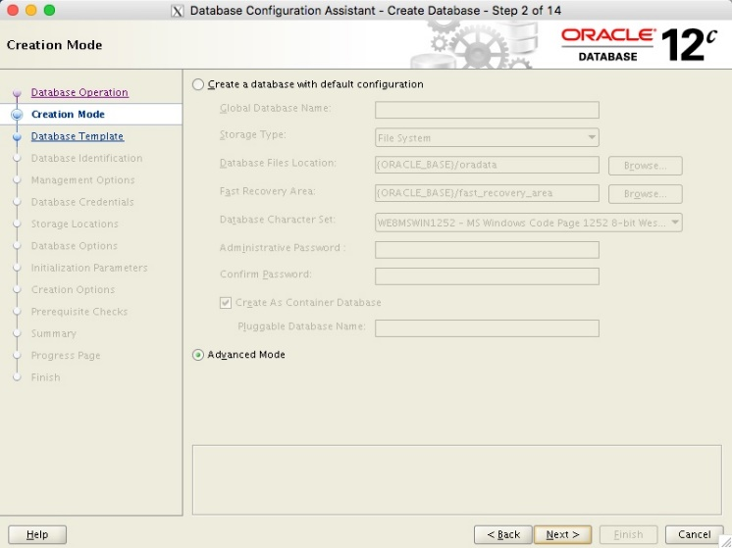

Select the template for the appropriate size of EM installation you need. In this case I've used the small option. Click the "Next" button.

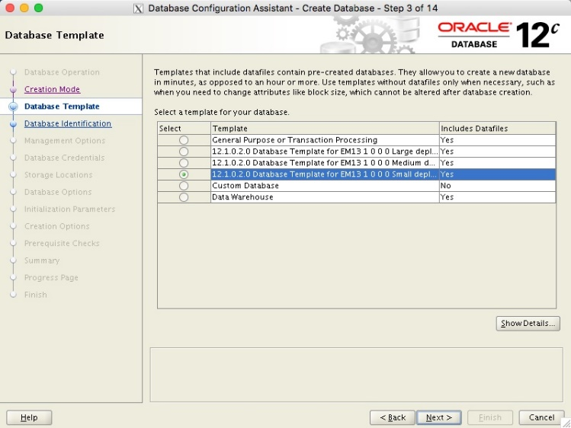

Enter the Global Database Name and SID, then click the "Next" button.

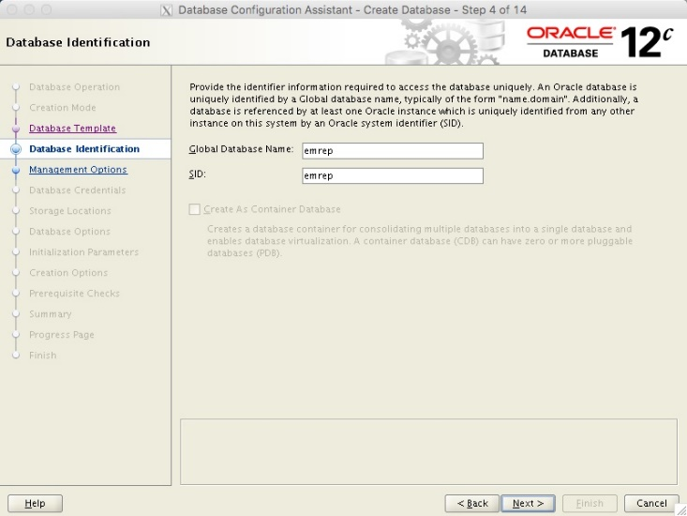

Make sure both the "Configure Enterprise Manager (EM) Database Express" and "Register with Enterprise Manager (EM) Cloud Control" options are unchecked, then click the "Next" button.

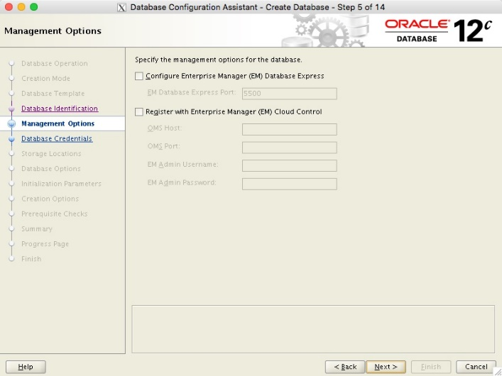

Enter the database credentials, then click the "Next" button.

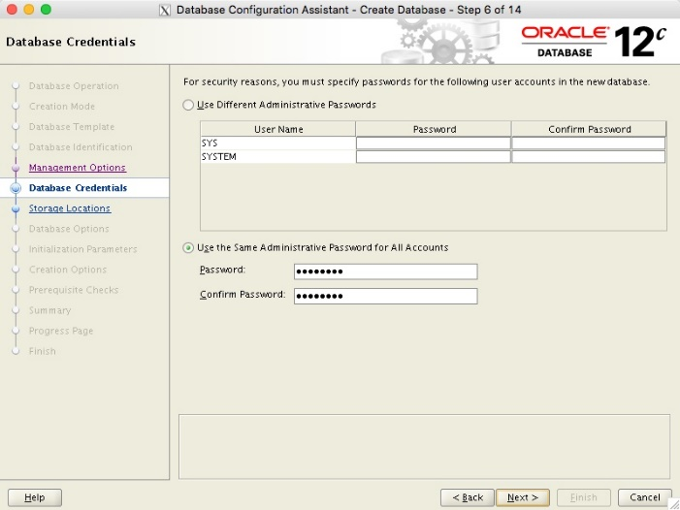

Enter the listener details and click the the "Next" button.

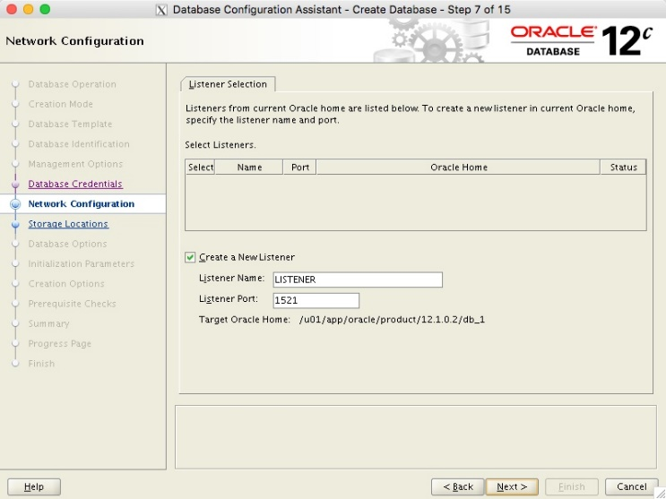

Choose the preferred location for the database files, then click the "Next" button.

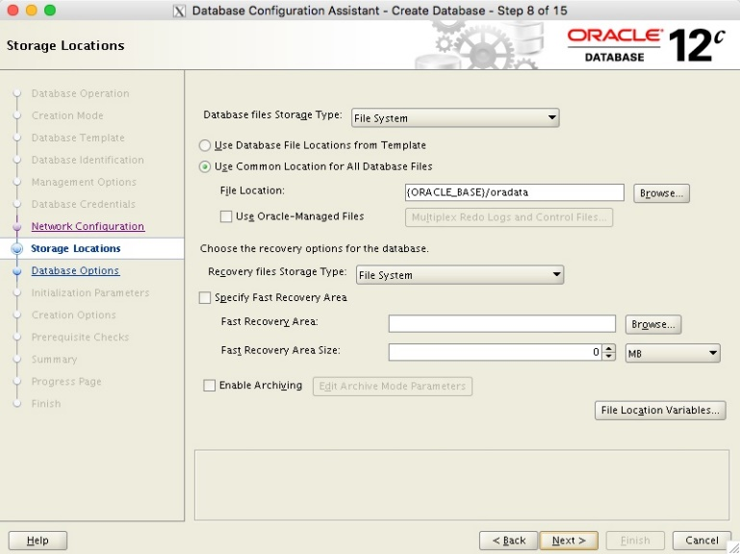

Accept the default settings and click on the "Next" button.

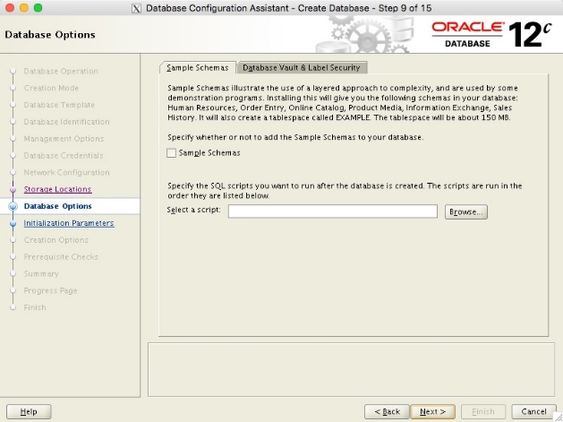

Amend the memory settings as desired, click on the "Character Sets" tab and select the "AL32UTF8" option and click the "Next" button. In this case I'm accepting the memory defaults.

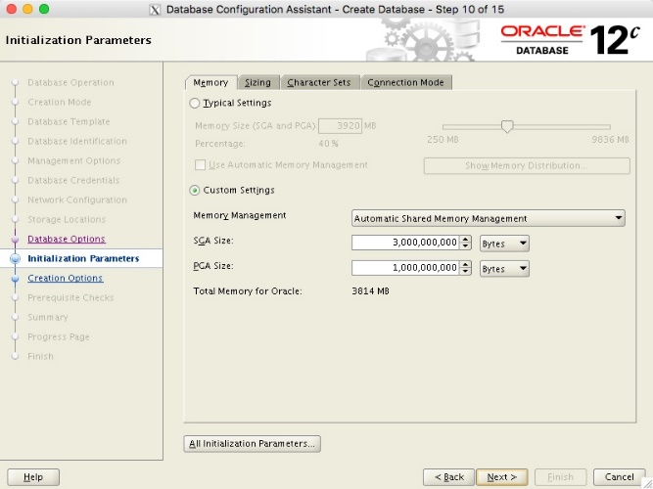

Click the "Next" button to create the database.

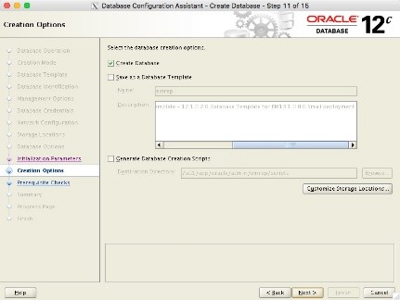

If you are happy with the summary information, click the "Finish" button.

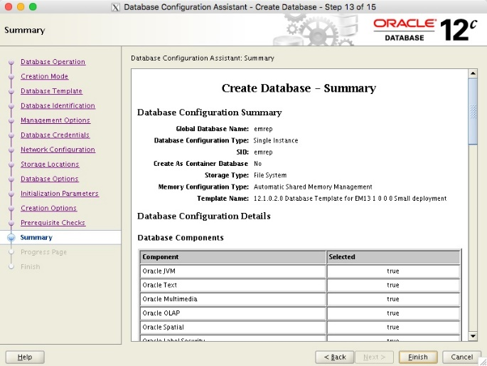

Wait while the database is created.

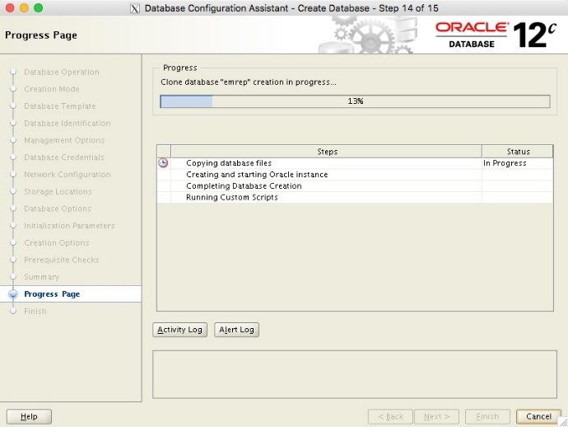

Once the database creation is complete, click the "Close" button.

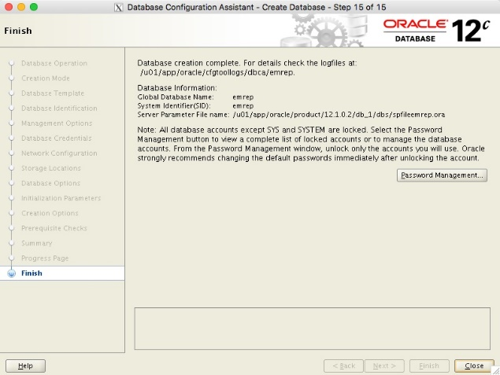

## Cloud Control 13c Installation

Make the following directories to hold the management server and agent. There are some restrictions on the possible path lengths, so don't make the directory structure too deep, especially for Windows installations.

$ mkdir -p /u01/app/oracle/middleware

$ mkdir -p /u01/app/oracle/agent

$ chmod u+x em13100_linux64.bin

$ ./em13100_linux64.bin

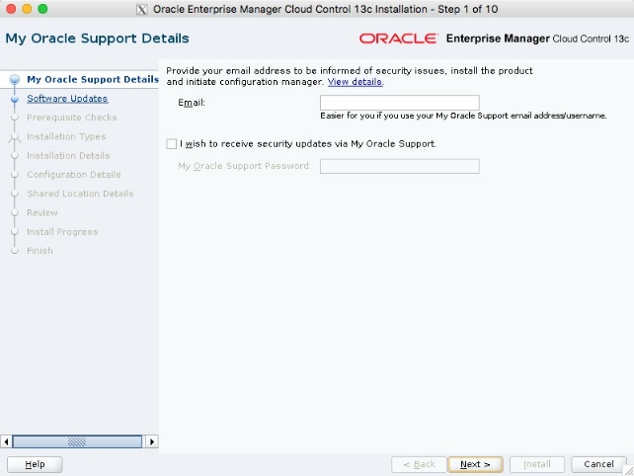

If you wish to check for updates, enter the required details, or check the "Skip" option and click the "Next" button.

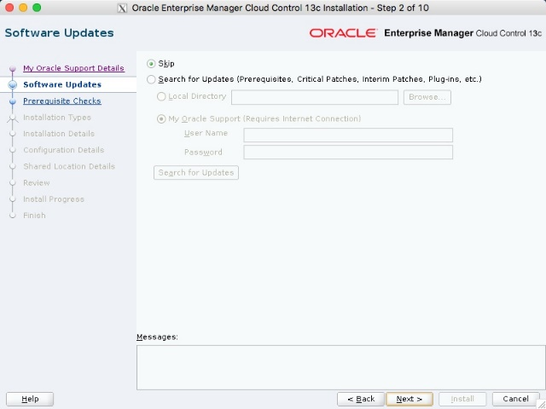

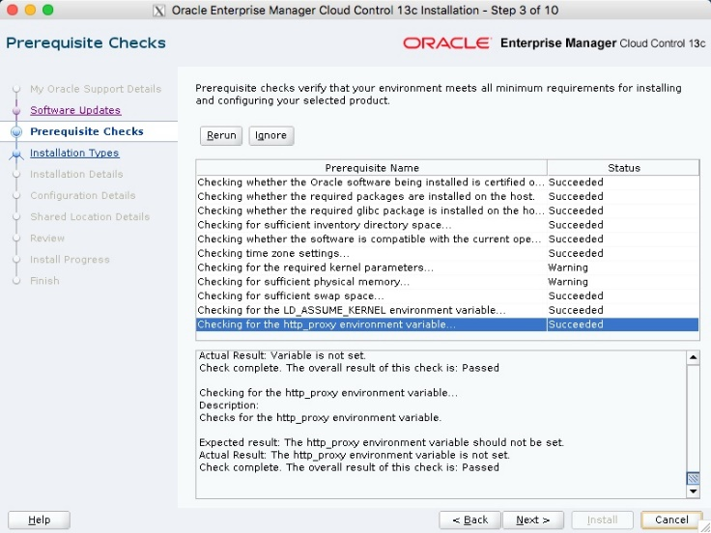

Select the "Create a new Enterprise Manager System" and "Simple" options, then click the "Next" button.

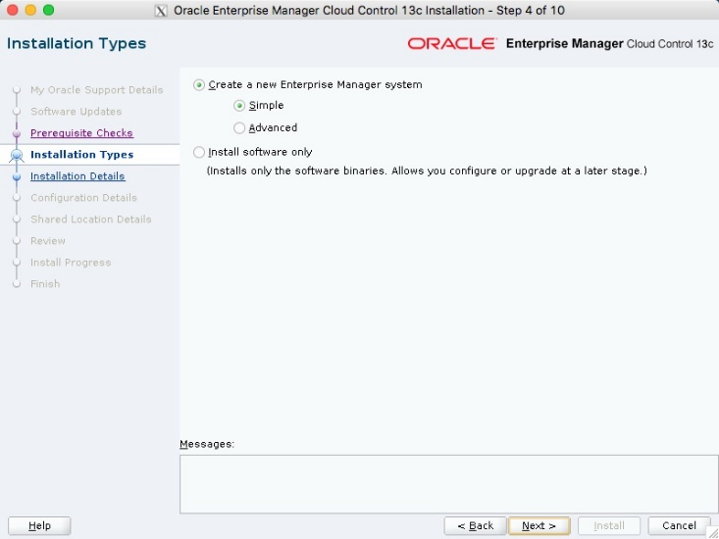

Enter the middleware and agent locations, then click the "Next" button.

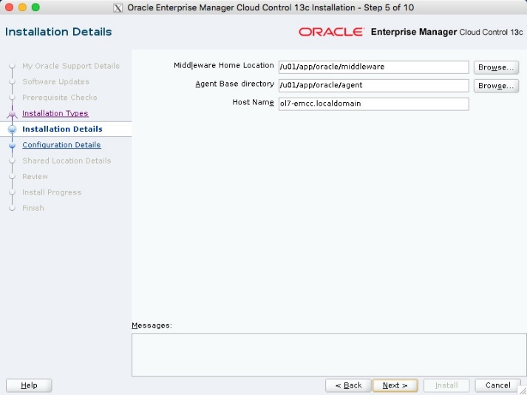

Enter the administrator password and database repository details, then click the "Next" button.

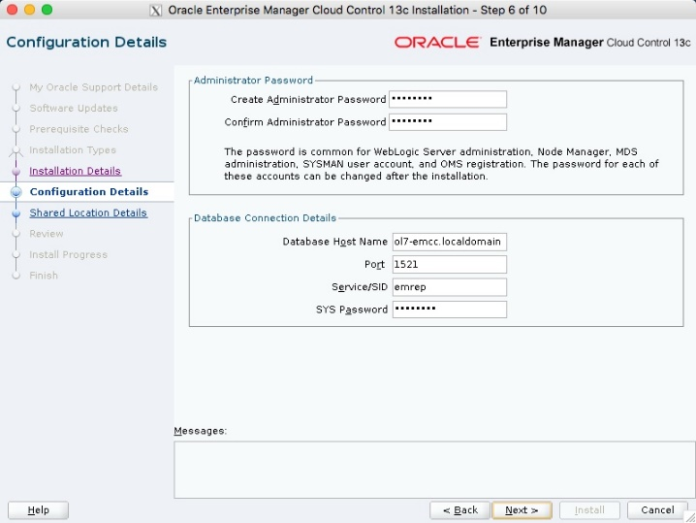

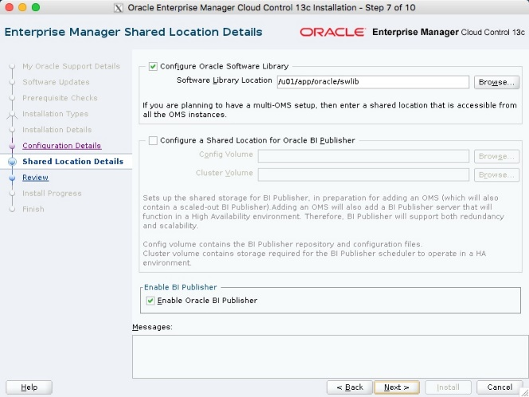

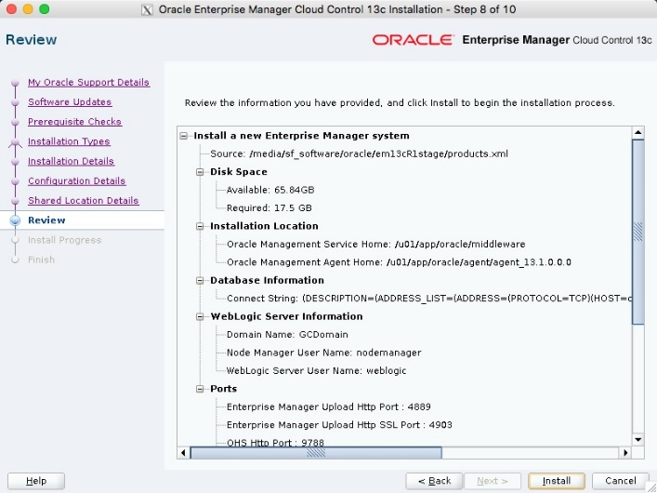

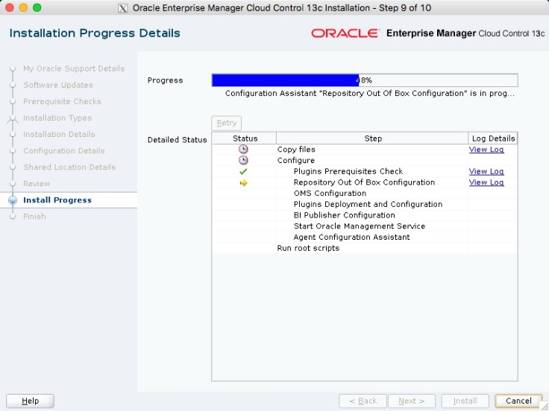

When prompted, run the root scripts, then click the "OK" button.

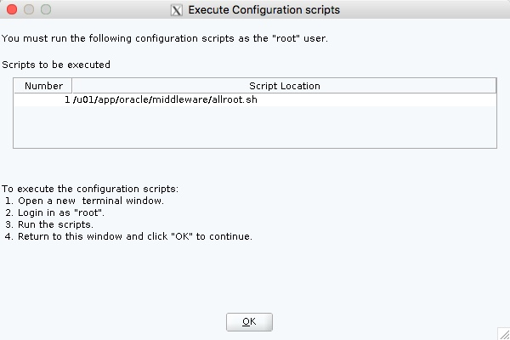

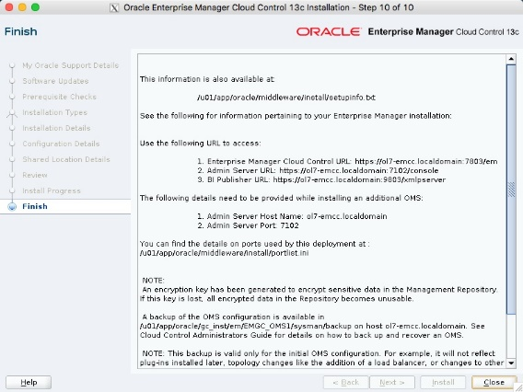

https://ol7-emcc.localdomain:7802/em

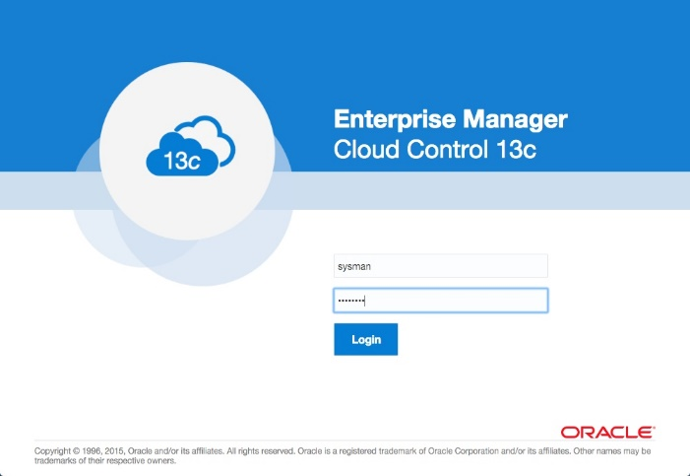

Use the following commands to turn on all components installed by this article.

#!/bin/bash

export ORACLE_HOME=/u01/app/oracle/product/12.1.0.2/db_1

export OMS_HOME=/u01/app/oracle/middleware

export AGENT_HOME=/u01/app/oracle/agent/agent_inst

# Start everything

$ORACLE_HOME/bin/dbstart $ORACLE_HOME

$OMS_HOME/bin/emctl start oms

$AGENT_HOME/bin/emctl start agent

Use the following commands to turn off all components installed by this article.

#!/bin/bash

export ORACLE_HOME=/u01/app/oracle/product/12.1.0.2/db_1

export OMS_HOME=/u01/app/oracle/middleware

export AGENT_HOME=/u01/app/oracle/agent/agent_inst

# Stop everything

$OMS_HOME/bin/emctl stop oms -all

$AGENT_HOME/bin/emctl stop agent

$ORACLE_HOME/bin/dbshut $ORACLE_HOME

**Integration weblogic & OEM:**

* OEM Cloud Control Home Page

[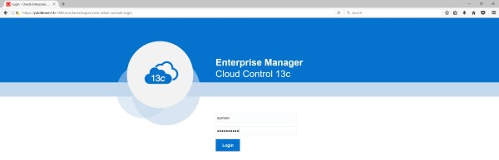](http://prasaddomala.com/wp-content/uploads/2016/12/WLS_OEM_01.jpg)

[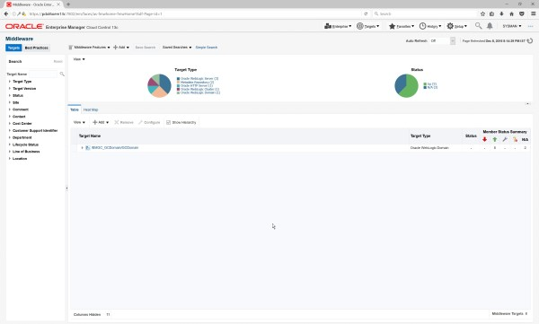](http://prasaddomala.com/wp-content/uploads/2016/12/WLS_OEM_02.jpg)

* Navigate to Setup -> Add target -> Add Target Manually

[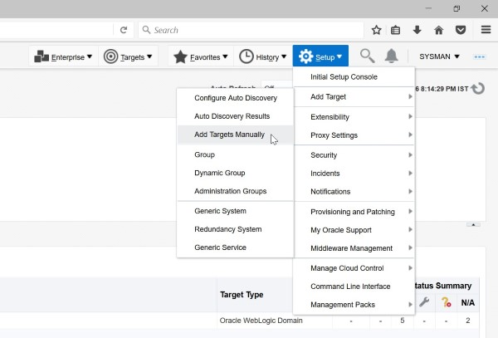](http://prasaddomala.com/wp-content/uploads/2016/12/WLS_OEM_03.jpg)

* Click Install Agent On Host

[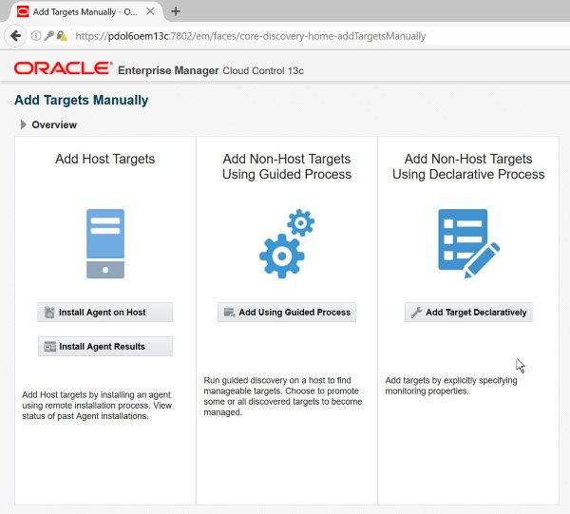](http://prasaddomala.com/wp-content/uploads/2016/12/WLS_OEM_04.jpg)

* Click Add. Provide Hostname (FQDN) and select Linux x86-64 as the Platform and click Next

[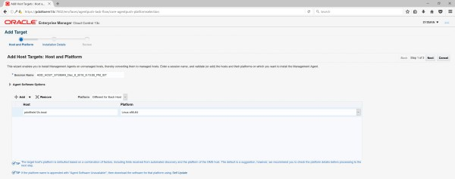](http://prasaddomala.com/wp-content/uploads/2016/12/WLS_OEM_05.jpg)

* Provide Agent Installation Directory as below
  + Installation Base Directory: /u01/app/oracle/product/oemagent
  + Instance Directory: /u01/app/oracle/product/oemagent/agent_inst

[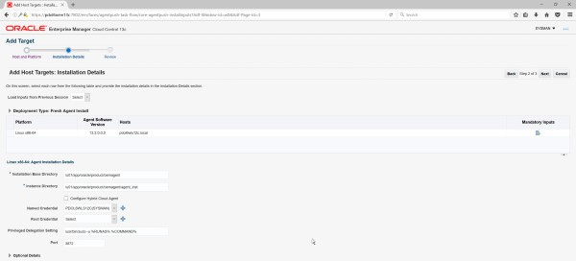](http://prasaddomala.com/wp-content/uploads/2016/12/WLS_OEM_07.jpg)

* Click “+” button next to Named Credentials and provide credentials of the user on target machine (WLS Machine) and click Next on Add Target Screen

[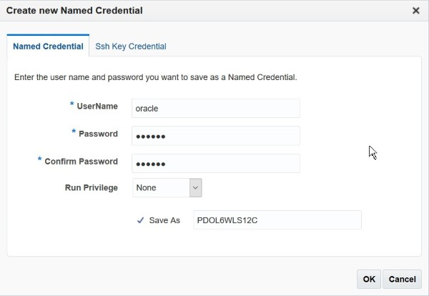](http://prasaddomala.com/wp-content/uploads/2016/12/WLS_OEM_06.jpg)

* Click Deploy Agent on review Screen

[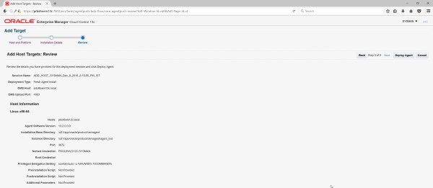](http://prasaddomala.com/wp-content/uploads/2016/12/WLS_OEM_08.jpg)

* Agent Deployment will be started. Below are the stages of agent deployment. Make sure each stage is successful.
  + Initialization
  + Remote Pre Requisite Check
  + Agent Deployment

[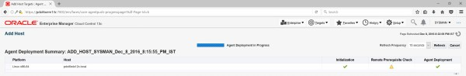](http://prasaddomala.com/wp-content/uploads/2016/12/WLS_OEM_09.jpg)

[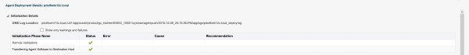](http://prasaddomala.com/wp-content/uploads/2016/12/WLS_OEM_10.jpg)

[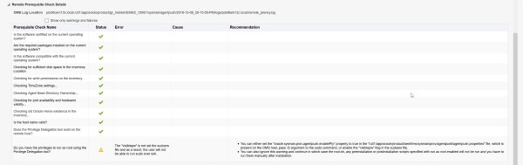](http://prasaddomala.com/wp-content/uploads/2016/12/WLS_OEM_11.jpg)

[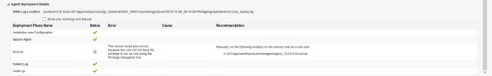](http://prasaddomala.com/wp-content/uploads/2016/12/WLS_OEM_12.jpg)

* Navigate to Setup -> Manage Cloud Control -> Agents

[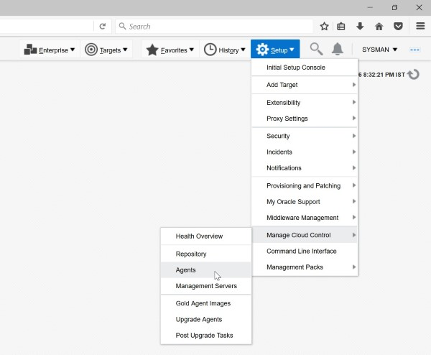](http://prasaddomala.com/wp-content/uploads/2016/12/WLS_OEM_13.jpg)

* Make sure the new Agent is added for WLS target machine and the status is UP

[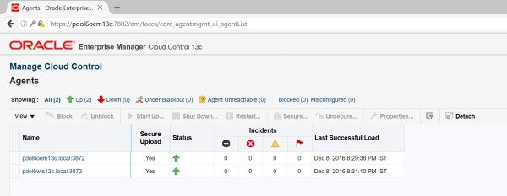](http://prasaddomala.com/wp-content/uploads/2016/12/WLS_OEM_14.jpg)

* Login to target WLS machine and verify if Agent and Instance Home Directories are created

[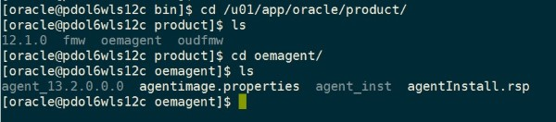](http://prasaddomala.com/wp-content/uploads/2016/12/WLS_OEM_15.jpg)

#### Oracle Weblogic Domain Discovery

* Navigate to Setup -> Add Target -> Add Targets Manually

[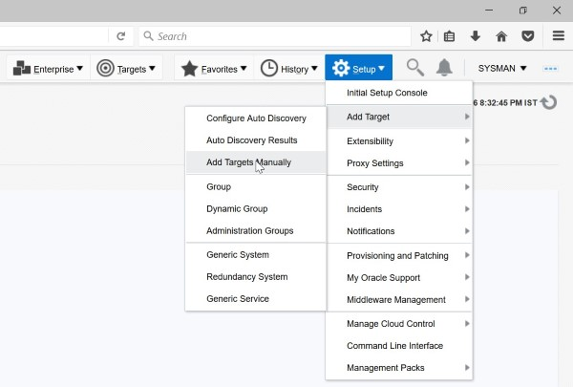](http://prasaddomala.com/wp-content/uploads/2016/12/WLS_OEM_16.jpg)

* Click “Add Using Guided Process”

[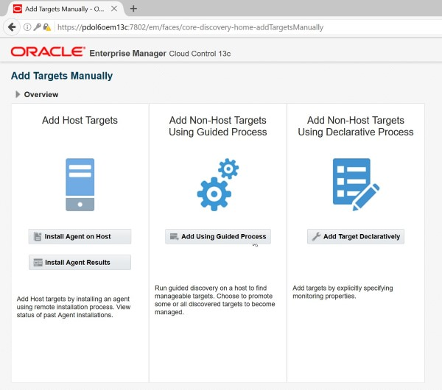](http://prasaddomala.com/wp-content/uploads/2016/12/WLS_OEM_17.jpg)

* Select “Oracle Fusion Middleware/Weblogic Domain” and click Add

[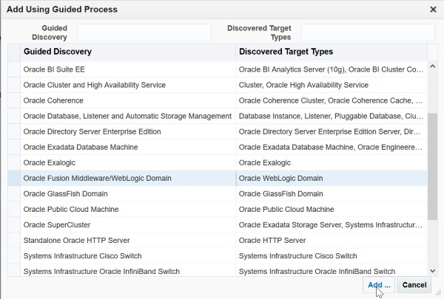](http://prasaddomala.com/wp-content/uploads/2016/12/WLS_OEM_18.jpg)

* Select target host from the available list and click Select

[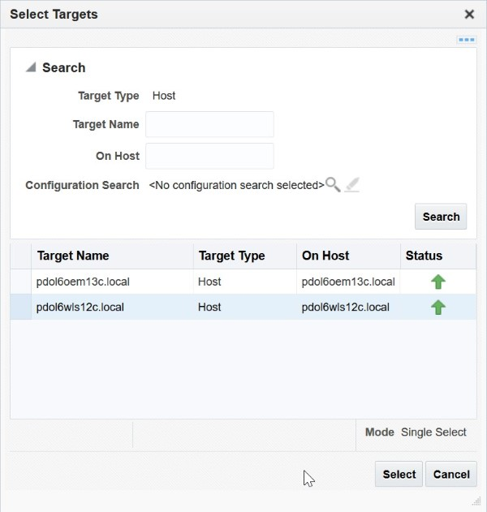](http://prasaddomala.com/wp-content/uploads/2016/12/WLS_OEM_19.jpg)

* Provide details of Weblogic Domain as per below screenshot and click Continue.

[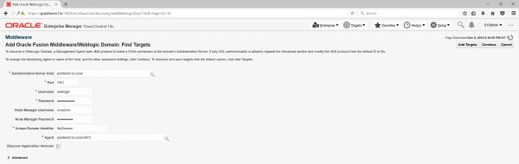](http://prasaddomala.com/wp-content/uploads/2016/12/WLS_OEM_20.jpg)

* Wait for the targets to be discovered and click Close

[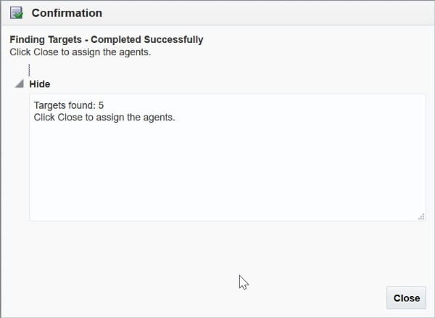](http://prasaddomala.com/wp-content/uploads/2016/12/WLS_OEM_21.jpg)

* Verify the list of discovered targets and click “Add Targets”

[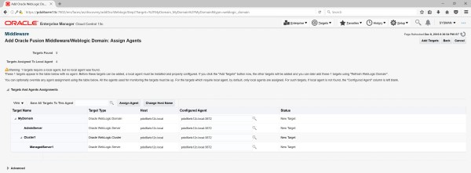](http://prasaddomala.com/wp-content/uploads/2016/12/WLS_OEM_22.jpg)

* Click Close on the Confirmation Screen

[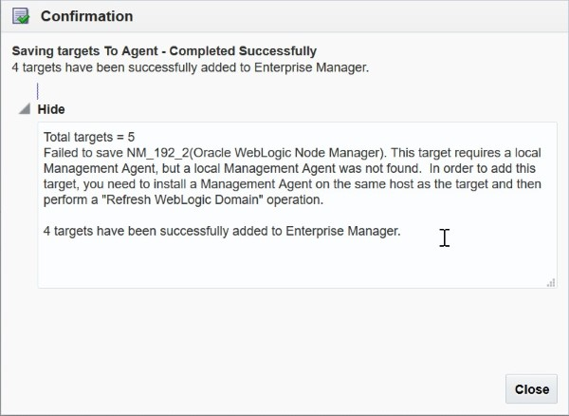](http://prasaddomala.com/wp-content/uploads/2016/12/WLS_OEM_23.jpg)

* Click OK on the Results Screen

[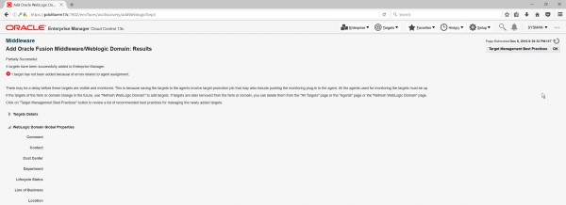](http://prasaddomala.com/wp-content/uploads/2016/12/WLS_OEM_24.jpg)

* Navigate to Middleware Home Page and make sure the Domain is added under the targets table

[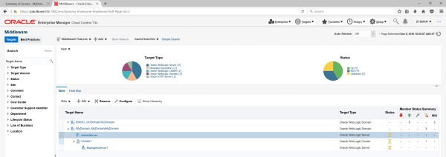](http://prasaddomala.com/wp-content/uploads/2016/12/WLS_OEM_25.jpg)

* Weblogic Managed Server Metrics Screen

[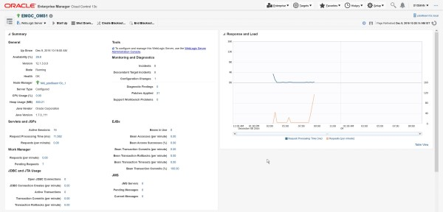](http://prasaddomala.com/wp-content/uploads/2016/12/WLS_OEM_26.jpg)

[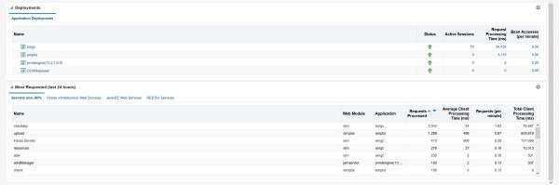](http://prasaddomala.com/wp-content/uploads/2016/12/WLS_OEM_27.jpg)